2026
Richard Mangan
U.T.G. Pty Ltd
1/27/2026
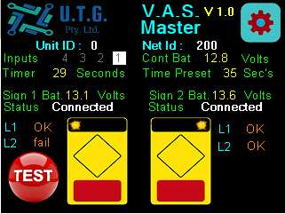
UTG-UC3

Wireless
V.A.S.
Controller
Instructions

Contents
1.0 Purpose of this document 3
2.0 Controller system overview 3
3.0 Display info 4
4.0 Configuration 5
4.1 Network 6
4.2 Device type/number 6
4.3 Number slaves 7
4.4 Flashing time 8
4.5 Clear time 8
4.6 Gap time 8
4.7 Lantern current 8
3.8 LCD intensity 8
6.0 Specification 9
7.0 Connections 9
9. Document Version table 10

Purpose of this document
This document is to give understanding of hardware and configuration of the UC3 controllers view controller displays
- Configure Controller
- Wiring controllers
- Diagnostics

2.0 Controller system overview
These can be setup as a single Master with 1 slave or 2 slaves, with the slaves operating (flashing) the lights at remote end and reporting status back to the master unit, the master unit controls timing of the lights based on settings in the master unit and trigger inputs.
The timing between the master unit and slave(s) are kept in sync via the wireless connection and in the event the master does loose connection the slave will continue to time as normal.

3.0 Display info
The above image shows the home page for a device configured as a Master controller
The display shows information as listed below
- Network address “200”
- Unit ID “0” , 0 is master
- Trigger input status
- Controller battery voltage
- Battery voltage for each slave unit
- Current Preset flash time value
- Current remaining flash time if triggered
- Connection status to each slave
- Image of each sign with flashing lanterns indicating operation status, note if lantern in failed state image will not flash this lantern.
- Lantern status fields , “OK”, “fail”
- TEST button
- Setup Button (top right corner)

4.0 Configuration
To change setting in control unit press the button in top right corner of display to see the next setup page as below, pressing the arrow button in top right corner will step to next setup page (lantern current and LCD intensity)
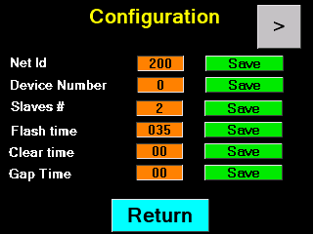
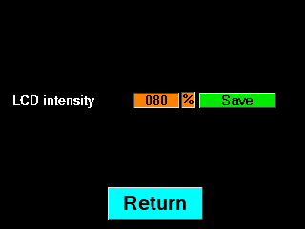

4.1 Network
The network address needs to be set the same for all devices on the same network, this is to stop other devices operating in same area conflicting with each other.
- Click on the orange number box to change number
- 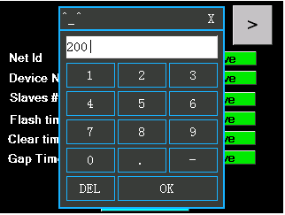
- After entering new number click save button.

4.2 Device type/number
The device number also determines if unit is a Master or Slave device
- “0” = Master
- “1” = slave 1
- “2” = slave 2
To change this number, click orange number box and enter new number then click Save

Note if ID = 1 or 2 selected the menu options change to suit a slave device.
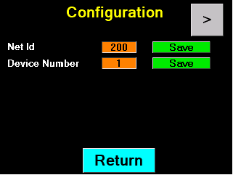
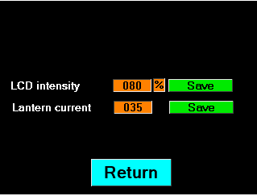

4.3 Number slaves
- Click on the orange number box to change number
- Click Save to save this setting
This setting is only available if set to Master controller, this setting changes the from view screen information.
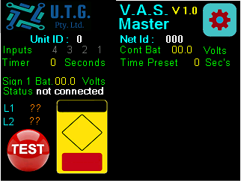

4.4 Flashing time
- Click on the orange number box to change number
- Click Save to save this setting
This setting changes the flash time of all slaves, a detection trigger on input starts this timer, when input 1 turns off the timer will start counting down, if a new trigger will reset timer.

4.5 Clear time
- Click on the orange number box to change number
- Click Save to save this setting
This setting is only used if you want to set up second detection for timer cancellation eg. Stop line loop, this time changes the main flash time to this value when input 2 triggered and counts down when input off.

4.6 Gap time
- Click on the orange number box to change number
- Click Save to save this setting
This time value disables the clear time trigger if last input 1 trigger was less than this time.
Eg
- If flash time = 60 seconds
- Clear time = 8 seconds
- Gap time = 15 seconds
When input 1 triggered 60 starts counting down, if trigger 2 input activated (stop line) within 15 seconds then don’t reset timer as this may be different car at stop line, so this gap time should be time from first detection zone to stop line detection zone.

4.7 Lantern current
- Click on the orange number box to change number
- Click Save to save this setting
If controller set to slave, then this setting is available.
The number represents ma x 10 eg 35 = 350ma
Range is from 30 to 100 or 300ma to 1000ma
Keep this setting below lantern specifications to allow to lantern current fluctuations due to temperature and battery voltages. If setting too high a failure will be displayed on status page on screen.
This setting is used to monitor lantern status.

3.8 LCD intensity
- Click on the orange number box to change number
- Click Save to save this setting
This setting is to change the back lighting of the LCD.

Note: screen will also blank after 5 minutes to reduce power consumption and screen burn in.

6.0 Specification
Supply voltage 12 – 24 VDC
- Trigger inputs 12 – 42 VAC – VDC
- Relay outputs 0- 60 VDC VAC
- Relay output 2 amps
- Lantern outputs 2 amps 24 volt max
- Antenna 920 Mhz required.
Note: Current setup for this firmware uses
- Lantern outputs 2 and 3 Alternating output 1 static
- Inputs 1 and 2
- Relays 1,2,3,4

7.0 Connections
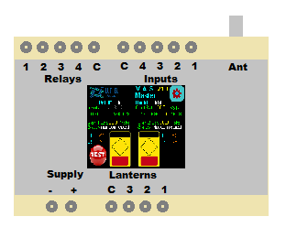
- Inputs
12 to 42 Vac or VDC input between C terminal and input number
- Lantern Outputs
12-24 VDC negative switching , connect lanterns between positive supply and output number.
Note use output 3 and output 2 for VAS sign application
C terminal connect to supply Pos if switching relays with inductive loads.

- Relay outputs
Voltage free contact 2 amps max between C terminal and output number
  - Output 1 on when sign 1 operating
  - Output 2 on when sign 2 operating
  - Output 3 on when Sign 1 Lanterns both OK
  - Output 4 on when sign 2 Lanterns both OK

9. Document Version table

Version | Notes | By | Date
1.0 | First version of document | R.J.M. | 27/01/26

